**IBM – NALAIYA THIRAN PROJECT**

**SMART FASHION RECOMMENDER**

**APPLICATION**

**INDUSTRY MENTOR : KRISHNA CHAITANYA**

**FACULTY MENTOR :AYSHA SUFREEN**

**TEAM ID :**PNT2022TMID37413

**TEAM LEADER :**MUHAMMED SHIBIL C V

**TEAM MEMBER :**JAVID BASHA J

**TEAM MEMBER :**MOHAMED AKIL H

**TEAM MEMBER :**YASAR ARAFARTH S

**ABSTRACT**

In recent years, the textile and fashion industries have witnessed an enormous amount of growth in fast fashion. On e-commerce platforms, where numerous choices are available, an recommendation system is required to sort, order, and efficiently convey relevant product content or information to users. Image-based fashion recommendation systems (FRSs) have attracted a huge amount of attention from fast fashion retailers as they provide a personalized shopping experience to consumers. With the technological advancements, this branch of artificial intelligence exhibits a tremendous amount of potential in image processing, parsing, classification, and segmentation. Despite its huge potential, the number of academic articles on this topic is limited. The available studies do not provide a rigorous review of fashion recommendation systems and the corresponding filtering techniques. To the best of the author’s knowledge, this is the first scholarly article to review the state-of-the-art fashion recommendation systems and the corresponding filtering techniques. In addition, this review also explores various potential models that could be implemented to develop fashion recommendation systems in the future.

Fashion is perceived as a meaningful way of self-expressing that people use for different purposes.It seems to be an integral part of every person in modern societies, from everyday life to exceptional events &occasions. Fashionable products are highly demanded, and consequently, fashion is perceived as a desirable and profitable industry. Although this massive demand for fashion products provides an excellent opportunity for companies to invest in fashion-related sectors, it also faces different challenges in answering their customer needs.

**TABLE OF CONTENT**

|  |  |  |
| --- | --- | --- |
| **CHAPTER** | **CONTENTS** | **PAGE NO** |
| **1** | **INTRODUCTION**  1.1 PROJECT OVERVIEW  1.2 PURPOSE | **05** |
| **2** | **LITERATURE SURVEY**  2.1 EXISTING PROBLEM  2.2 REFERENCES  2.3 PROBLEM STATEMENT DEFINITION | **06** |
| **3** | **IDEATION & PROPOSED SOLUTION**  3.1 EMPATHY MAP CANVAS  3.2 IDEATION & BRAINSTROMING  3.3 PROPOSED SOLUTION  3.4 PROBLEM SOLUTION FIT | **08** |
| **4** | **REQUIREMENT ANALYSIS**  4.1 FUNCTIONAL REQUIREMENT  4.2 NON-FUNCTIONAL REQUIREMENTS | **13** |
| **5** | **PROJECT DESIGN**  5.1 DATA FLOW DIAGRAMS  5.2 SOLUTION & TECHNICAL ARCHITECTURE  5.3 USER STORIES | **14** |
| **6** | **PROJECT PLANNING & SCHEDULING**  6.1 SPRINT PLANNING & ESTIMATION  6.2 SPRINT DELIVERY SCHEDULE  6.3 REPORTS FROM JIRA | **17** |

|  |  |  |
| --- | --- | --- |
| **7** | **CODING & SOLUTIONING**  7.1 FEATURE 1  7.2 FEATURE 2  7.3 DATABASE SCHEMA | **21** |
| **8** | **TESTING**  8.1 TEST CASES  8.2 USER ACCEPTANCE TESTING | **38** |
| **9** | **RESULTS**  9.1 PERFORMANCE METRICS | **39** |
| **10** | **ADVANTAGES & DISADVANTAGES** | **40** |
| **11** | **CONCLUSION** | **41** |
|  |  | **42** |
| **12** | **FUTURE SCOPE** |  |
| **13** | **APPENDIX**  SOURCE CODE  GITHUB LINK | **43** |

# 1.INTRODUCTION

**1.1 PROJECT OVERVIEW**

Clothing is a kind of symbol that represents people’s internal perceptions through their outerappearance. It conveys information about their choices, faith, personality, profession, social status, and attitude towards life. Therefore, clothing is believed to be a nonverbal way of communicating and a major part of people’s outer appearance. Recent technological advancements have enabled consumers to track current fashion trends around the globe, which influence their choices . The fashion choices of consumers depend on many factors, such as demographics, geographic location, individual preferences, interpersonal influences, age, gender, season, and culture . Moreover, previous fashion recommendation research shows that fashion preferences vary not only from country to country but also from city to city . The combination of fashion preferences and the abovementioned factors associated with clothing choices could transmit the image features for a better understanding of consumers’ preferences .

**1.2 PURPOSE**

There is currently no existing system that is capable of recommending clothes based on the occasion. Different occasions call for different clothing. Moreover, a lot of fashion is based on the color combinations of outfits. A person with no or little fashion sense will have a hard time to decide on clothes that leave a lasting impression. The proposed Fashion Recommendation System is intended to be used by individual users in order to store images of the clothes that they own in what is called a digital wardrobe and also to get recommendations by the system on what clothes to wear for a given occasion. The main aim of the project is to recommend the most appropriate clothes for a given occasion based on the clothes existing in the user’s wardrobe to relieve the user of the burden of making decisions about what clothing to wear. Such a system should be capable of helping someone who has no fashion sense to wear clothes that leave a good impression on others. The system should be such that it is easily accessible and easy to take advantage of the various features that it provides. One of the features should be the ability to store images that the user uploads into a wardrobe. A wardrobe is a very useful entity that the user can use to view and manage the images of clothes that they have uploaded.

# 2. LITERATURE SURVEY

**2.1 EXISTING PROBLEM:**

In existing system only simple web application and their rating has been implemented in existing system, An ecommerce product recommendation engine is a piece of technology that displays recommended products to shoppers throughout your store. It uses machine learning to get smarter and show increasingly relevant products to shoppers based on their interests and previous browsing behaviour

**2.2 REFERENCES:**

1. Global Info Research: Global Fast Fashion Apparel Market 2021 by Key

Countries, Companies, Type and Application. Global Info Research, Hong Kong, 2021.

1. Hou, M., Wu, L., Chen, E., Li, Z., Zheng, V. W., & Liu, Q.: Explainable fashion recommendation: A semantic attribute region guided approach. In Proceedings of the 28th Twenty-Eighth International Joint Conference on Artificial Intelligence, 2019; pp.

4681- 4688.

1. Hidayati, S. C., Hsu, C. C., Chang, Y. T., Hua, K. L., Fu, J., & Cheng, W. H.: What Dress Fits Me Best? Fashion Recommendation on the Clothing Style for Personal Body Shape. In Proceedings of the 26th ACM International Conference on Multimedia

(MM

'18). Association for Computing Machinery, New York, NY, USA, 2018; pp. 438-446.

1. Wang, H., Wang, N., & Yeung, D. Y.: Collaborative Deep Learning for Recommender Systems. In Proceedings of the 21th CM SIGKDD International

Conference on

Knowledge Discovery and Data Mining, New York, 2015; pp. 1235- 1244.

**2.3 PROBLEM STATEMENT DEFINITION**

The personal information collected by recommenders raises the risk of unwanted exposure of that information. Also, malicious users can bias or sabotage the recommendations that are provided to other users. In recent years, the textile and fashion industries have witnessed an enormous amount of growth in fast fashion. On ecommerce platforms, where numerous choices are available, an efficient recommendation system is required to sort, order, and efficiently convey relevant

product content or information to users.

* + - The problem of the work is to design static web applications deployments with customer deployment
    - Lack of interaction between application and user
    - User need to navigate across multiple pages to choose right product
    - Confusion in choosing product
    - Lack of sales
    - Complex User Interface.
    - Lack of proper guidance.

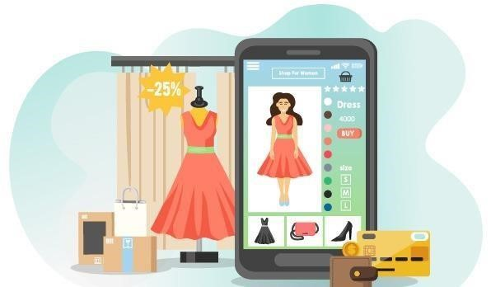

**3.IDEATION & PROPOSED SOLUTION**

**3.1 EMPATHY MAP CANVAS:**

An empathy map is a simple, easy-to-digest visual that captures knowledge about

a user’s behaviours and attitudes. It is a useful tool to helps teams better understand

their users. Creating an effective solution requires understanding the true problem and the person who is experiencing it. The exercise of creating the map helps participants consider things from the user’s perspective along with his or her goals and challenges. An empathy map is a collaborative tool teams can use to gain a deeper insight into their

customers.

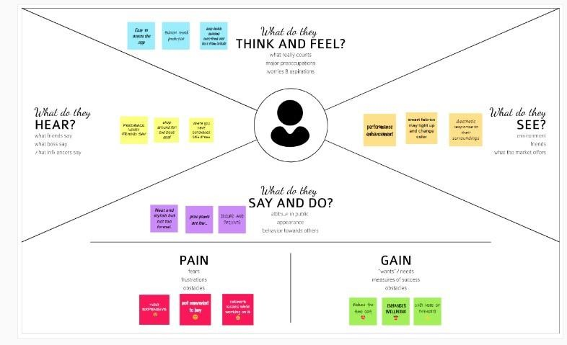

**3.2 IDEATION & BRAINSTROMING:**

A group problem-solving technique that involves the spontaneous contribution of ideas from all members of the group. The mulling over of ideas by one or more individuals in an attempt

to devise or find a solution to a problem.

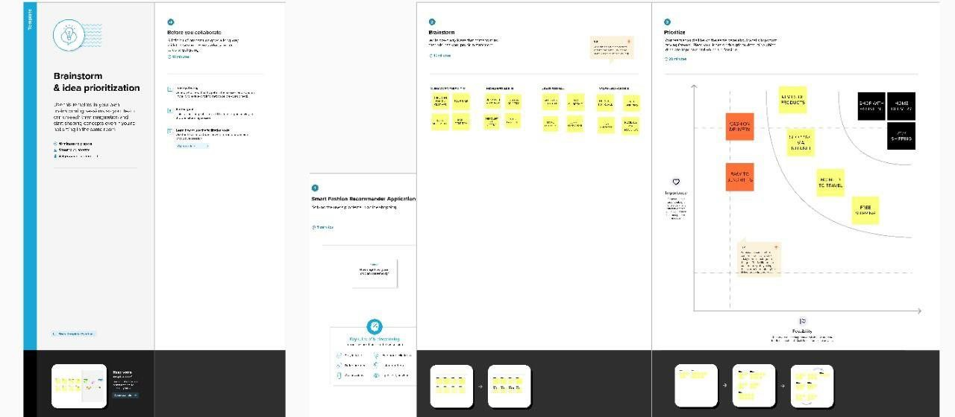

**3.3 PROPOSED SOLUTION:**

|  |  |  |
| --- | --- | --- |
| **S.No.** | **Parameter** | **Description** |
| 1. | Problem Statement (Problem to be solved) | * Customers feels difficult when Search many websites to find Fashion clothes and accessories that suits them. * A new innovative solution came up through which can directly make online shopping based on the choice of the user without any search. * It can be done by using the chatbot which can be achieved by a smart fashion recommender application. |
| 2. | Idea / Solution description | * Customers directly make online shopping based on customer choice without any search * User can be able to mention their preferences by interacting with chatbot. * The user must receive a notification on order confirmation/failure. * The chatbot must gather feedback from the user at the end of order confirmation. |
| 3. | Novelty / Uniqueness | * The customer will talk to Chat Bot regarding the Products. Get the recommendations based on information provided by the user * Instead of searching manually a chatbot will help to find the right product effectively, with this feature user can save time and it is an easy process, chat keep sending a notification about new collections |
| 4. | Social Impact / Customer Satisfaction | * The customer are provided with the fashion clothes they are seeking for using chat Bot. * The model can recommend products that are more suitable to the customer. * Directly do online shopping based on customer |
| 5. | Business Model (Revenue Model) | * The customer purchase the product that are provided by chat Bot and generate avenue * Better experience and Feasibility. |
| 6. | Scalability of the Solution | * The application can increase scalability by providing various kinds of product that the users looking for. * Storing user preferences along with the product in the browser cookie will enable it to provide a response instantly and allows for fetching related products. |

**3.4 PROBLEM SOLUTION FIT**:

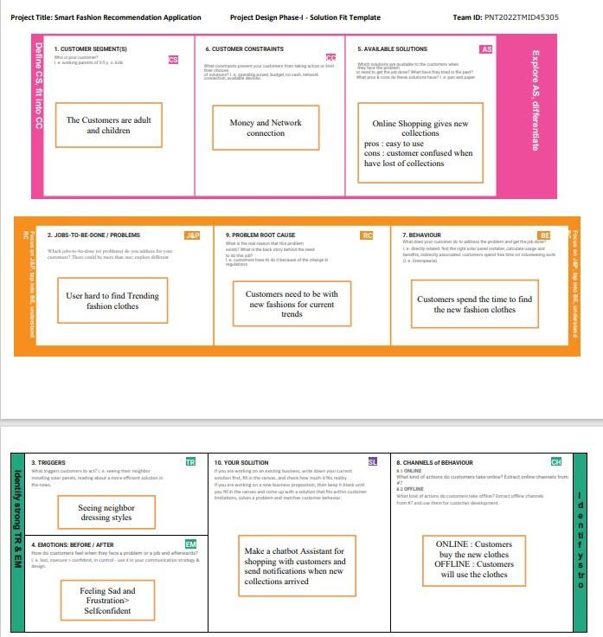

**4.REQUIREMENT ANALYSIS**

**4.1 FUNCTIONAL REQUIREMENT:**

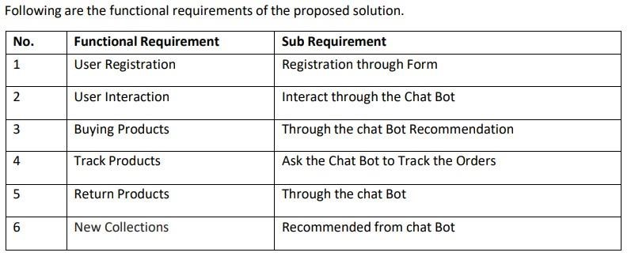

**4.2 NON-FUNCTIONAL REQUIREMENTS:**

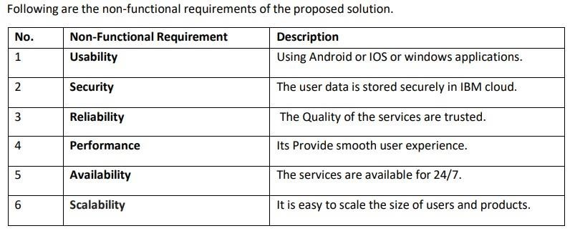

**5.PROJECT DESIGN**

**5.1 DATA FLOW DIAGRAMS:**

A Data Flow Diagram (DFD) is a traditional visual representation of the information flows within a system. A neat and clear DFD can depict the right amount of the system requirement graphically. It shows how data enters and leaves the system, what changes the information,

and where data is stored.

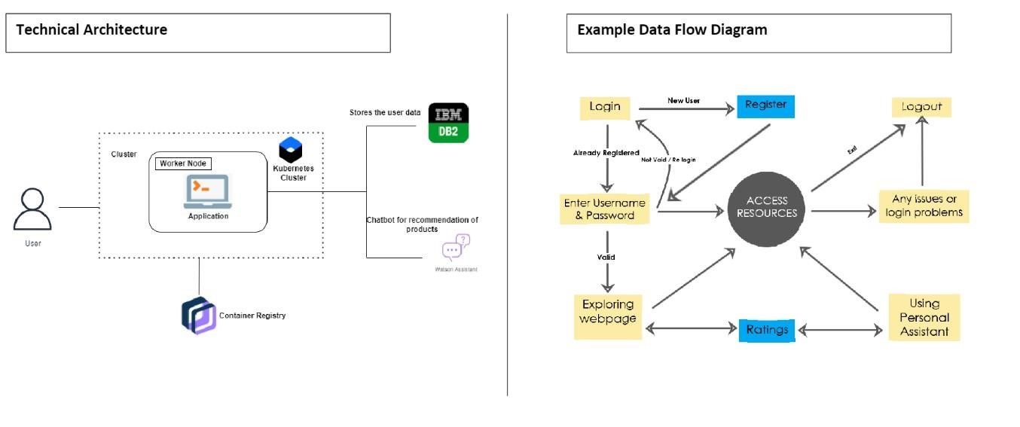

**5.2 SOLUTION & TECHNICAL ARCHITECTURE:**

We have developed a new innovative solution through which you can directly do your online shopping based on your choice without any search. It can be done by using the chatbot. In this project you will be working on two modules:

* Admin
* User

The solution is implemented in such a way as to improve the interactivity between customers

and applications. The chatbot sends messages periodically to notify offers and preferences.

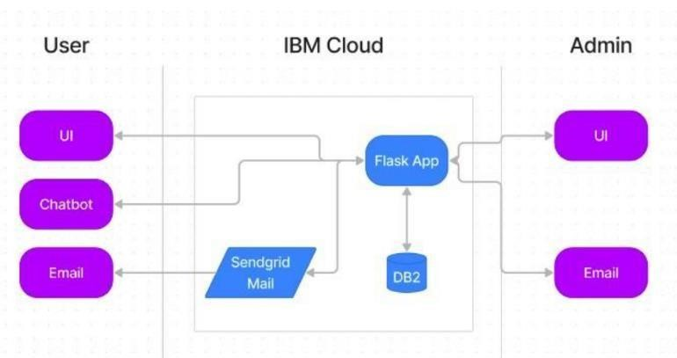

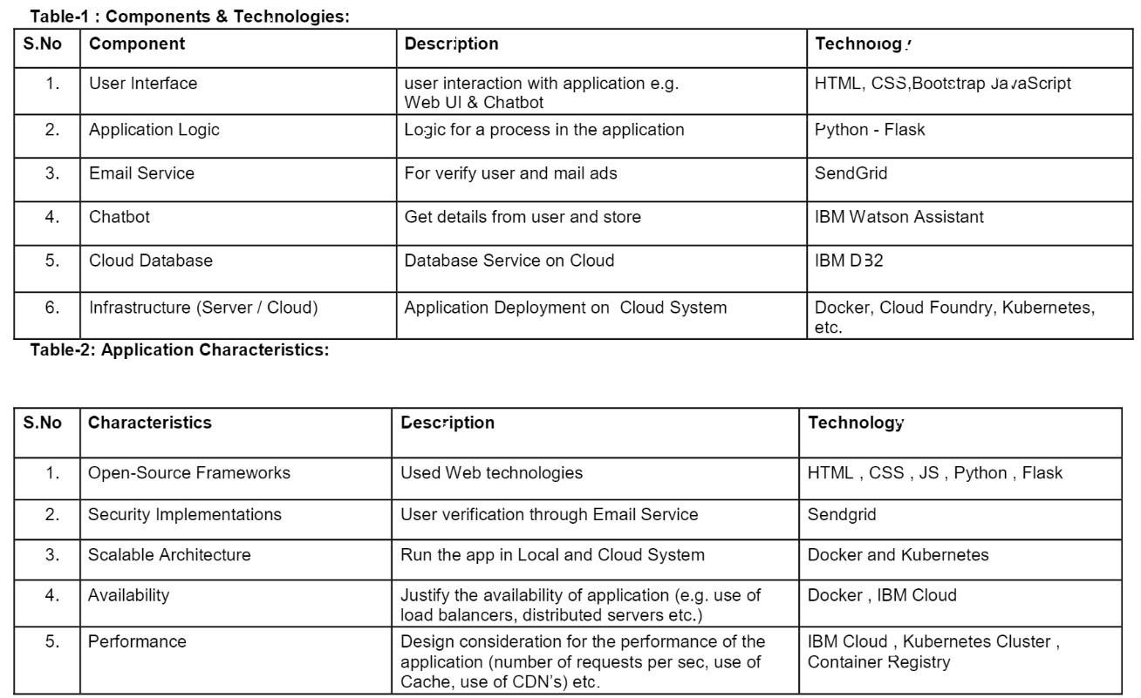

**5.3 USER STORIES:**

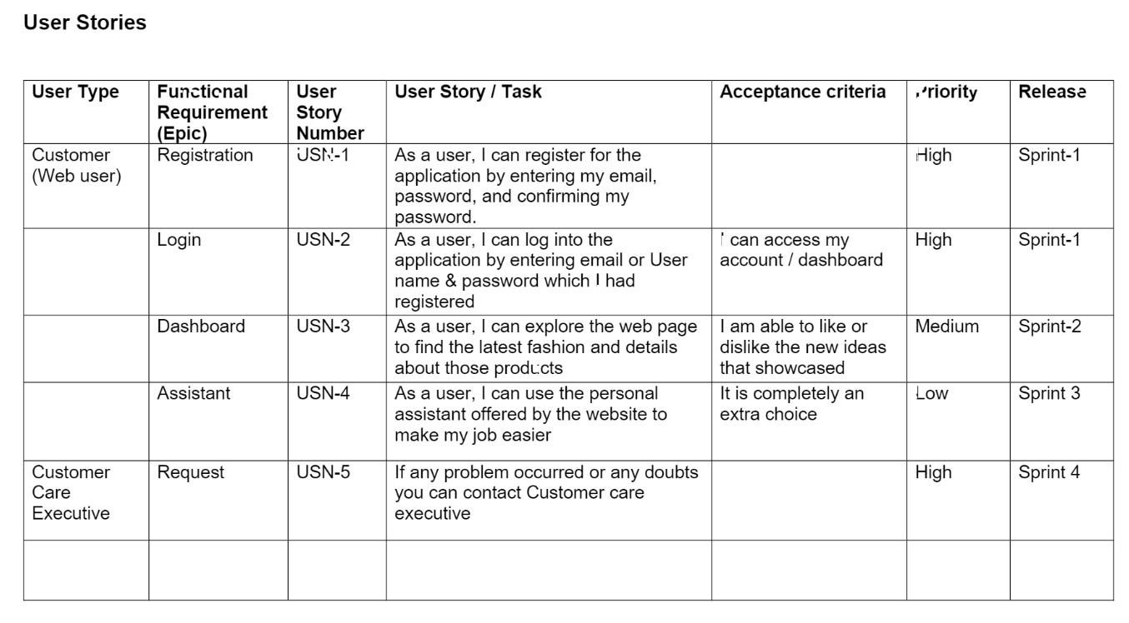

**6.PROJECT PLANNING & SCHEDULE 6.1**

**SPRINT PLANNING & ESTIMATION:**

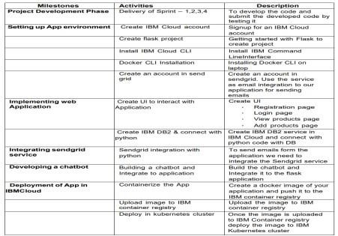

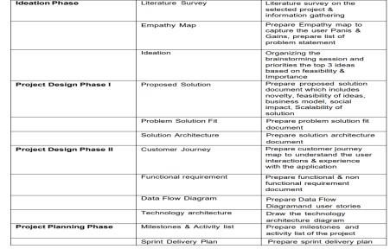

**6.2 SPRINT DELIVERY SCHEDULE:**

|  |  |  |  |  |  |  |
| --- | --- | --- | --- | --- | --- | --- |
| **Sprint** | **Functional**  **Requirement**  **(Epic)** | **User story number** | **User story /Task** | **Story points** | **Priority** | **Team Members** |
| Sprint-1 | User Panel | USN-1 | The user will login into the website and go through the  products available on the website | 20 | High | Muhammed Shibil  Javid Basha J  Mohamed Akil H  Yasar Arafarth S |
| Sprint-2 | Admin  Panel | USN-2 | The role of the admin is to check out the database about the stock and have a track of all the things that the users are purchasing. | 20 | High | Muhammed Shibil  Javid Basha J  Mohamed Akil H  Yasar Arafarth S |
| Sprint-3 | Chat Bot | USN-3 | The user can directly talk to chatbot regarding the products .Get the recommendations based on information provided by the user | 20 | High | Muhammed Shibil  Javid Basha J  Mohamed Akil H  Yasar Arafarth S |
| Sprint-4 | Final  Delivery | USN-4 | Container of applications using Docker Kubernets and deployment the applications. create the documentation and final submit the application | 20 | High | Muhammed Shibil  Javid Basha J  Mohamed Akil H  Yasar Arafarth S |

|  |  |  |  |  |  |  |  |
| --- | --- | --- | --- | --- | --- | --- | --- |
| **Sprint** | **Total story points** | **Duration** | **Sprint**  **Start**  **Date** | **Sprint End**  **Date**  **(Planned)** | **Story**  **Points**  **Completed**  **(as on**  **Planned**  **End Date)** | **Sprint**  **Date(Actual)** | **Release** |
| Sprint-1 | 20 | 6 Days | 24 OCT 2022 | 29 OCT 2022 | 20 | 29 OCT 2022 |  |
| Sprint-2 | 20 | 6 Days | 31 OCT 2022 | 05 NOV 2022 | 20 | 05 NOV 2022 |  |
| Sprint-3 | 20 | 6 Days | 07 NOV 2022 | 12 NOV 2022 | 20 | 12 NOV 2022 |  |
| Sprint-4 | 20 | 6 Days | 14 NOV 2022 | 19 NOV 2022 | 20 | 19OV 2022 |  |

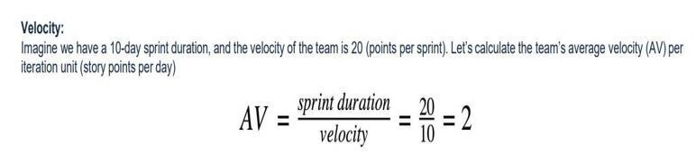

**6.1 REPORTS FROM JIRA:**

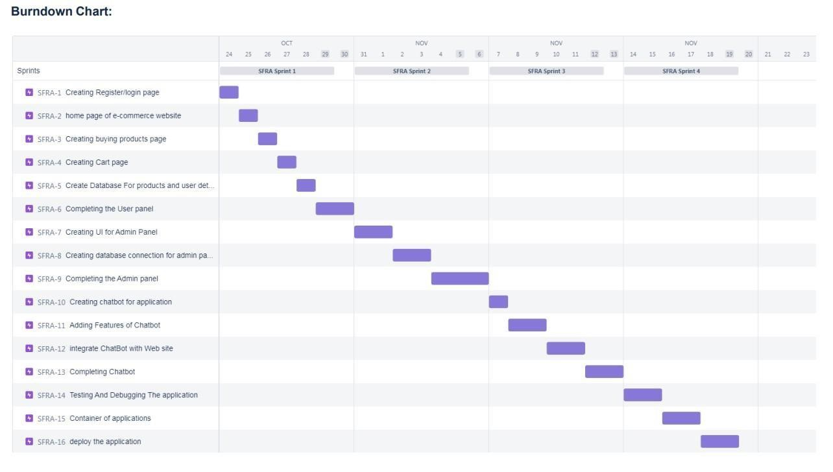

**7. CODING & SOLUTIONING**

**7.1 FEATURE-1:**

**HOMEPAGE.HTML:**

<html>

<head>

<title> SOLO SHOPPING </title>

</head>

<style>

*{ margin:

0;

padding:

0;

font-family: "Times New Roman", Times, serif;

}

.main{ width: 100%; background: linear-gradient(to top,rgba(0,0,0,0.5),rgba(0,0,0,0.5)50%); backgroundposition: center; background-size: cover; height: 100%; fontfamily: "Times New Roman", Times, serif;

}

.navbar{ width: 100%; height: 75px; margin: auto;

}

.icon{ width: 200px; float: left; height: 70px; } .logo{

color:#FFFFFF; font-size: 35px;

padding-left: 20px; float: left; paddingtop: 10px;

}

.menu{ width: 400px; float: left; height: 70px; } ul{ float: left; display: flex; justifycontent: center; alignitems: center;

} ul li{ list- style: none; margin-left: 62px; margin-top: 27px; fontsize: 15px;

} ul li a{

textdecoration: none; color:

#FFFFFF;

font-weight: bold; transition: 0.4s ease-

inout; }

ul li a:hover{ color: rgb(98, 246, 152);

}

.search{ width: 330px; float: left; margin-left: 270px;

}

.srch{

width: 200px; height: 40px; background: transparent; border: 1px solid rgb(98, 246, 152); margin-top: 13px; color: #FFFFFF; border-right: none; font-size: 16px; float: left; padding: 10px; border-bottom-left-radius:

5px; border-top-left-radius:

5px;

}

.btn{ width: 100px; height:

40px; background:rgb(98, 246, 152)

; border: 2px solid rgb(98, 246, 152); margin-top: 13px; color: #FFFFFF; font-size: 15px; borderbottom-rightradius: 5px; border-bottomright-radius: 5px;

}

.btn:focus{ outline: none;

}

.srch:focus{ outline:

none;

}

.content{ width: 1200px; height: auto; margin: auto; color: #800080; position: relative; }

.content.par{ paddingleft: 20px; paddingbottom: 25px;

letter-spacing: 1.2px; line-height: 30px;

}

.content h1{

font-size: 50px; padding-left: 20px; margin-top: 9%; letterspacing: 2px;

}

.content .cn{ width: 160px; height: 40px; background: rgb(98, 246, 152); border: none;

|  |  |
| --- | --- |
| margin-bottom: | 10px; |
| margin-left: | 20px; |
| fontsize: | 18px; |
| borderradius: | 10px; |
| cursor: | pointer; |

transition: .4s ease;

}

.content .cn a{ text-decoration: none; color: #FBE7A1; transition: .3s ease;

}

.cn:hover{ backgroundcolor: #FBE7A1;

}

.content span{ color:rgb(98, 246, 152); font-size:

60px;

}

.form{ width: 250px; height: 380px;

background: linear-gradient(to top,hsla(89, 43%,

51%, 0.3)); position: absolute; top: -20px; left:

870px; border-radius: 10px; padding: 25px;

}

.form h2{ width:

220px;

text-align: center; color:rgb(98,

246, 152); font-size: 22px;

border-radius:

10px; margin:

2px; padding:

8px;

}

.form input{ width: 240px; height: 35px; background: rgba(0, 255,

0, 0.5);

}

.form input{ width: 240px; height:

35px; background: rgba(0, 255, 0, 0.5); border-bottom: 1px solid rgb(98, 246, 152); border-top: none; border-right: none; borderleft: none; color: #fff; font-size:

15px; letter-spacing:

1px; margin-top: 30px;

}

.forminput:focus{ outline:

none;

}

::placeholder{ color:

#fff;

}

.btnn{ width: 240px; height: 40px;

background: rgb(98, 246, 152); border: none; margin-

top: 30px; font-size: 18px; borderradius

: 10px; cursor: pointer; color: #fff; transition:

0.4s ease;

}

.btnn:hover{ background: #fff; color: rgb(98, 246, 152);

}

.btnn a{ textdecoration: none; color: #000; font-weight: bold;

}

.form .link{

font-size: 17px; paddingtop: 20px; text-align: center;

}

.form .link a{ textdecoration: none; color: rgb(98, 246,

152);

}

.liw{

padding-top: 15px; paddingbottom: 10px; text-align: center;

}

</style>

<body>

<div class="main">

<div class="navbar">

<div class="icon">

<h2 class="logo">FASHIONZZ</h2>

</div>

<div class="menu">

<ul>

<li><a href="#">HOME</a></li>

<li><a href="#">ABOUT</a></li>

</ul>

</div>

<div class="search">

<input class="srch" type="search" name="" placeholder="TYPE TO

SEARCH"><a href="#"><button class="btn">SEARCH</button></a>

</div>

<img src="C:\Users\HP\Downloads\fashion-banner-people-cartooncharactersflatvector-illustration-isolated-fashion-banner-people-cartooncharacters190292392.jpg">

</div>

</div>

</body>

</html>

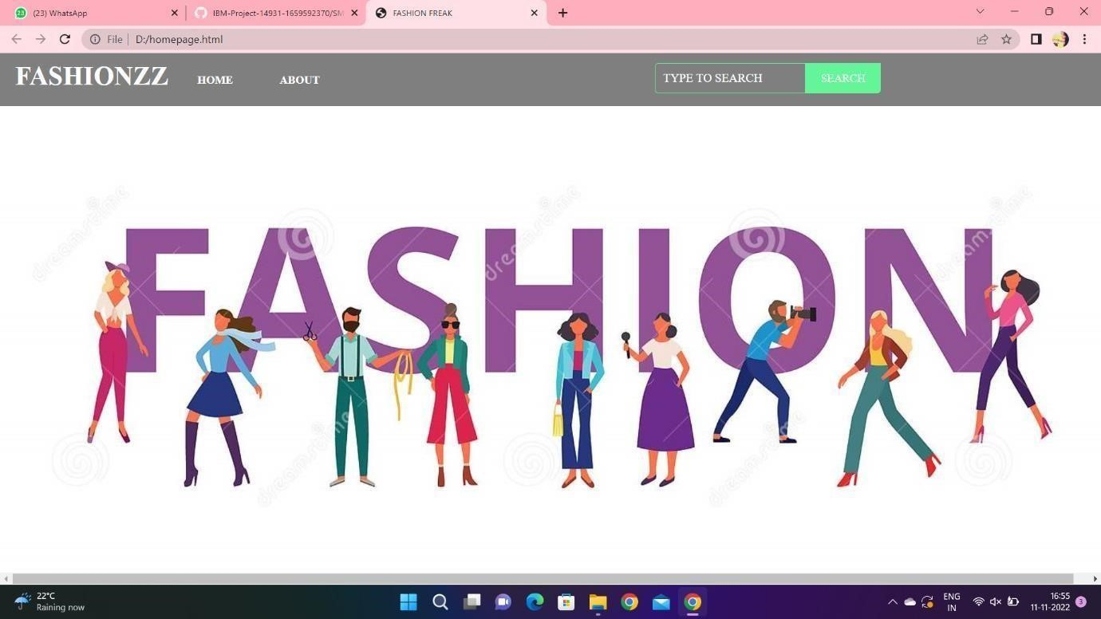

**7.2 FEATURE 2:**

**FINALHOME.HTML:**

<html>

<head>

<meta name="viewpoint" content="width=device-width, initial-scale=1.0">

<title>SOLO SHOPPING</title>

<link rel="stylesheet" href="https://storagedemo-madzh.s3.jptok.cloudobjectstorage.appdomain.cloud/MadmukFinalhomecss.css"></head>

<body>

<nav>

<a class="logo" href="MadFinalhome.html"><h2>SOLO SHOPPING</h2></a>

<ul>

<li><input class="srch" type="search" name="" placeholder="TYPE TO

SEARCH">

<a href="#"><button class="btn">SEARCH</button></a></li>

<li><a href="#">HOME</a></li>

<li><a href="#">FEATURES</a></li>

<li><a href="#">ABOUT</a></li>

</ul>

<imgsrc="https://storagedemo-madzh.s3.jp-tok.cloud-object- storage. App domain .cloud/images/profile.jpeg" class="user-pic" onclick="toggle Menu()">

<div class="sub-menu-wrap" id="sub menu">

<div class="sub-menu">

<div class="user-info">

<imgsrc="https://storagedemo-madzh.s3.jp-tok.cloud object storage.

app domain. cloud/images/profile.jpeg">

<h2>NAME</h2>

</div>

<hr>

<a href="#" class="sub-menu-link">

<img src="https://storagedemo-madzh.s3.jptok.cloudobjectstorage.appdomain.cloud/images/profile.jpeg">

<p>EDIT PROFILE</p>

</a>

<a href="#" class="sub-menu-link"><imgsrc="https://storagedemo-madzh.s3.jptok.cloudobjectstorage.appdomain.cloud/images/settings.jpeg">

<p>SETTING & PRIVACY</p>

</a>

<a href="#" class="sub-menu-link">

<imgsrc="https://storagedemo-madzh.s3.jptok.cloudobjectstorage.appdomain.cloud/images/help.jpeg">

<p>HELP</p>

</a>

<a href="/Login" class="sub-menu-link">

<imgsrc="https://cdn-icons-png.flaticon.com/512/56/56805.png">

<p>LOGOUT</p>

</a>

</div>

</div>

</nav>

<div class="Banner">

<div class="Bannerimg1">

<imgimg class="image" src="https://img.freepik.com/freephoto/joyful-parisian-womanberetsunglasses-points-place-text-purple-wall_19753124604.jpg?w=2000"></div>

<div class="Ad content">

<h1><br>BEST FASHION FOR WOMEN</br></h1>

<br>ADD THESE NEW LAUNCHES TO YOUR CART NOW...</br>

</div>

</div>

<div class="row start">

<div class="columnst"><div class="dep img">

<img class="image" src="https://cdn0.weddingwire.in/article/2617/original/1280/jpg/107162wedding-dressesfor-girls-

6.jpeg"></div><div class="Bottom">WEDDING & FESTIVE</div></div>

<div class="columnst"><div class="dep img"><img class="image" src="https://previews.123rf.com/images/vadymvdrobot/vadymvdrobot1801/vadymvdrobo t18 0102335/94122785-full-length-image-of-smiling-asian-woman-in-businessclothesandeyeglasses-holding-smartphone-while.jpg"></div>

<div class="Bottom">BACK TO DESK</div>

</div>

<div class="columnst"><div class="depimg">

<img class="image" src="https://i.pinimg.com/474x/29/00/fa/2900fa4d1599631766420338e531b2b2.jpg"></div><div class="Bottom">VACAY MOOD</div></div>

<div class="columnst"><div class="depimg"><img class="image" src="https://img.faballey.com/images/Product/DRS02948Z/1.jpg"></div><div class="Bottom">PARTY ALL NIGHT</div></div>

</div>

<div class="Banner">

<div class="Bannerimg2"><imgimg class="image"

src="https://bluejay.com.my/wp-content/uploads/2021/12/Kids-clothes-Hong-

Kongseed.jpg"></div>

<div class="Adcontent2">

<h1><br>KIDS FASHION</br></h1>

<br>LET OUR FUTURE BE STYLISH.....</br>

</div>

</div>

<div class="row">

<div class="column"><div class="depimg">

<img class="image" src="https://cdn.shopify.com/s/files/1/0266/6276/4597/files/floral_ethnic_wear_for_kids_ by_ utsa.jpg?v=1597833877"></div><div class="Bottom">ETHNIC WEAR</div>

</div>

<div class="column"><div class="depimg"><img class="image"

src="https://i.pinimg.com/736x/8a/f8/59/8af859d60ef9667726b206e1be2378e4.jpg"></div><div class="Bottom">WINTER WEAR</div></div>

<div class="column"><div class="depimg"><img class="image"

src="https://i.pinimg.com/474x/9a/c2/85/9ac28569bd3bade0aa23bd74aaa8c0a9.jpg"></div><div class="Bottom">DRESSES & JUMPSUITS</div></div>

<div class="column"><div class="depimg"><img class="image"

src="https://i.pinimg.com/564x/1b/c1/d5/1bc1d56f08959760738a0386f231d3fc.jpg">

</div><div class="Bottom">TOPS & TEES</div></div>

</div>

<div class="Banner">

<div class="Bannerimg1"><imgimg class="image" src="https://images.hindustantimes.com/rf/image_size_630x354/HT/p2/2018/01/30/Pictu res/ _21667342-05ba-11e8-90ea-37dc70df54a3.jpg"></div>

<div class="Adcontent">

<h1><br>MENS FASHION</br></h1>

<br>WE ALSO PROVIDE TRENDY COLLECTIONS FOR MEN..ALWAYS

"MEN WILL BE MEN"</br>

</div>

</div>

<div class="row">

<div class="column"><div class="depimg"><img class="image"

src="https://encrypted-tbn0.gstatic.com/images?q=tbn:ANd9GcRPYVjlrL-

LxLn_nhnDfHJx09_dUQsTRgkM69nENo7WKE6EKe555GjYDI7leLNGsKyGvR8&usqp= CAU"></div><div class="Bottom">T-SHIRTS & POLOS</div></div>

<div class="column"><div class="depimg"><img class="image" src="https://encrypted- tbn0.gstatic.com/images?q=tbn:ANd9GcTIFeIqHpb2srr3FnKvSDnAUdz225j0v _ IjoKuIZzvS2O5LHuyxBNYzfy8HgQ_Hi6WbDQ&usqp=CAU"></div><div class="Bottom">CASUAL SHIRTS</div></div>

<div class="column"><div class="depimg"><img class="image" src="https://assets.myntassets.com/dpr_1.5,q_60,w_400,c_limit,fl_progressive/assets/i mages/

10498568/2020/6/10/f1bc48ac-9997-4be1-8ce3-

81cc6d5e61061591736177979HRX-byHrithik-Roshan-Men-Grey-Solid-RegularFit-Training-Jo-1.jpg"></div><div class="Bottom">SPORTS WEAR</div></div>

<div class="column"><div class="depimg"><img class="image"

src="https://images.express.com/is/image/expressfashion/0037_04105431_0512?cache=on

&

wid=361&fmt=jpeg&qlt=75,1&resmode=sharp2&op_usm=1,1,5,0&defaultImage=PhotoComi ng-Soon"></div><div class="Bottom">SWEATSHIRTS & JACKETS</div></div></div>

<div class="Banner">

<div class="Bannerimg2"><img class="image"

src="https://lh3.googleusercontent.com/KDJ_WZU_7c-

GHi14G03oqXb6ZSgTiDJr8L7Rid5jA9pRPAdUOgfQQYAPDLGN9Sn3eJC6B1F4qchid_

0 mHWn_jficXrs=w400-rw"></div>

<div class="Adcontent2">

<h1><br>ACCESSORIES</br></h1>

<br>THE ANOTHER THING WHICH MAKES A PERSON FASHIONABLE IS

ACCESSORIES</br>

</div>

</div>

<div class="rowend">

<div class="columnend"><div class="depimg"><img class="image" src="https://5.imimg.com/data5/FJ/AH/MY-42396081/combo-sets-28americandiamondjewellery-29500x500.jpg"></div><div class="Bottom">JEWELLERY</div></div>

<div class="columnend"><div class="depimg"><img class="image" src="https://encrypted- tbn0.gstatic.com/images?q=tbn:ANd9GcTaoxLoX2lgaVWFtaGkCvyrozucBLTpaV4LJd9 xx

2sRoqoums9kp9soRVXOKw6_rkVxsZk&usqp=CAU"></div><div class="Bottom">SUNGLASSES</div></div>

<div class="columnend"><div class="depimg"><img class="image" src="https://encrypted- tbn0.gstatic.com/images?q=tbn:ANd9GcRJKjvaIU1qatbXinxMNRfWE338fXEl7t69TQ&u sq p=CAU"></div><div class="Bottom">WATCHES</div></div>

<div class="columnend"><div class="depimg">

<img class="image" src="https://encrypted-

tbn0.gstatic.com/images?q=tbn:ANd9GcQSWDKgpQeZ-

3VNR79SfaVGVvqOawrkZiLdNfSpjNNQJNI6hl8cJg0Qs_DZfpJtizUst0&usqp=CAU"></div>

<div class="Bottom">HANDBAGS & CLUTCHES</div></div>

</div>

<script>

let subMenu = document.getElementById("subMenu"); function toggleMenu()

{

subMenu.classList.toggle("open-menu");

}

</script>

</body>

<footer>

<div class="footer"><H1>BE HAPPY</H1></div></footer>

</html>

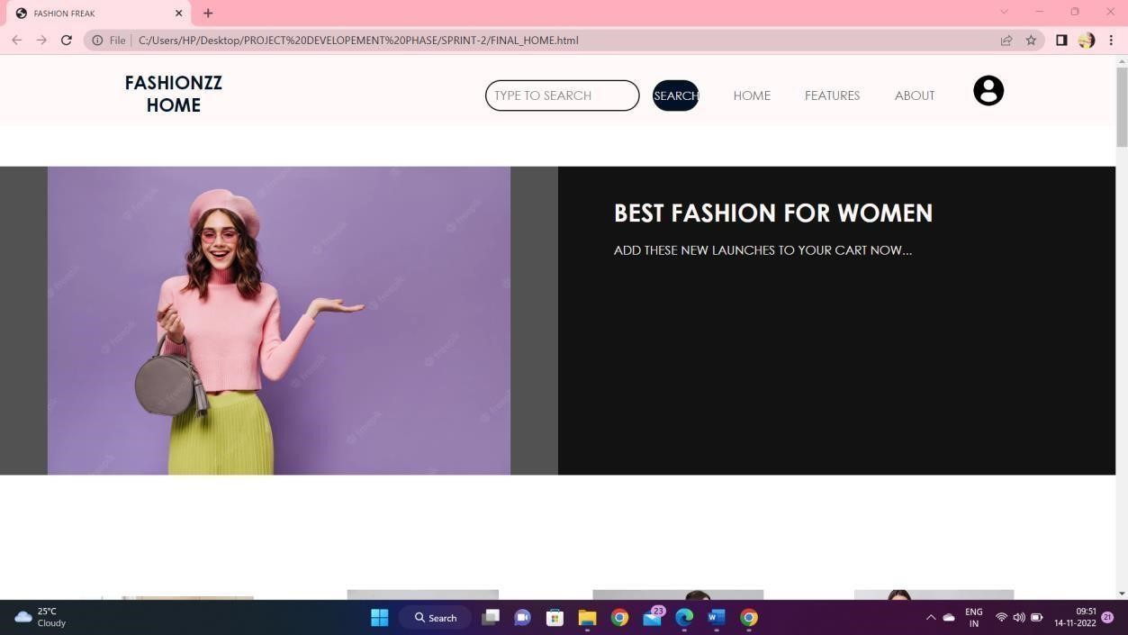

**7.3 DATABASE SCHEMA:**

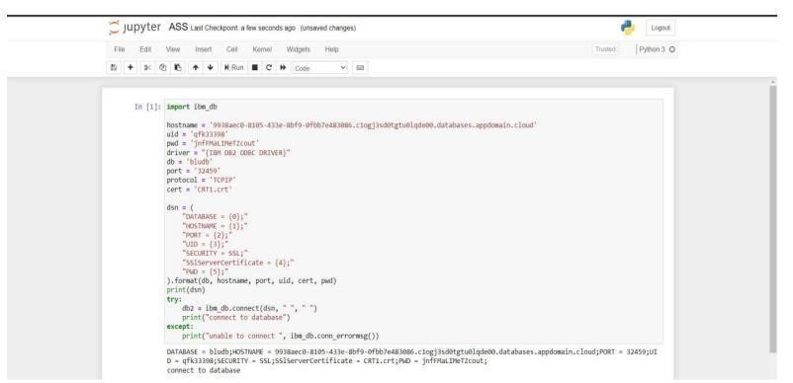

**8. TESTING 8.1 TEST CASES:**

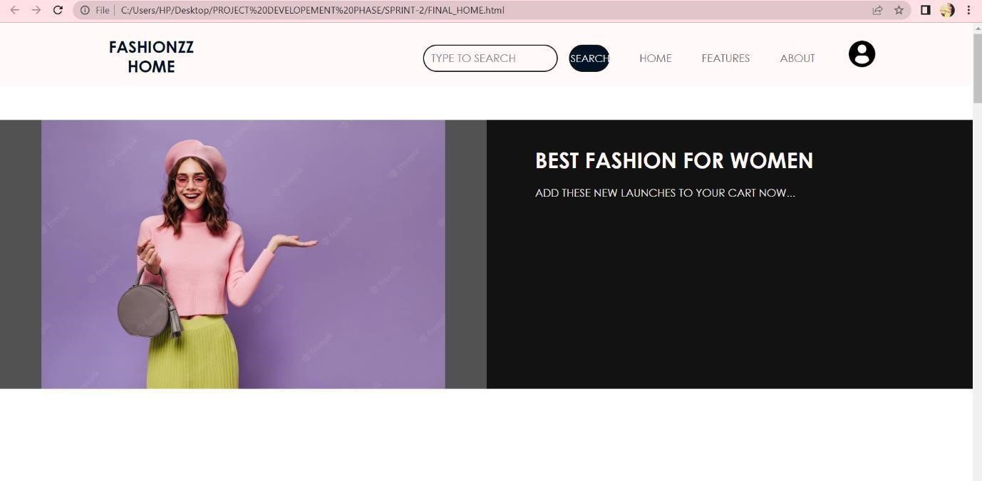

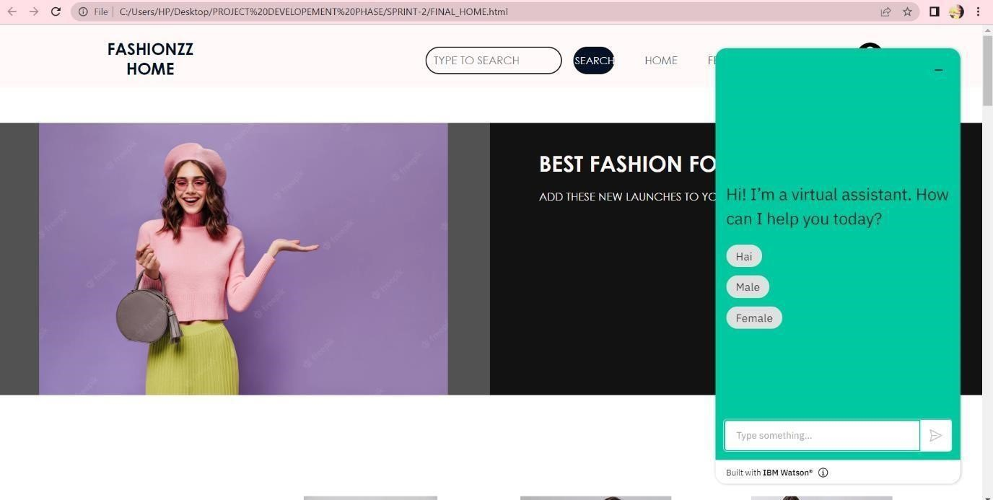

**9.RESULTS**

**9.1 PERFORMANCE METRICS:**

The performance of a recommendation algorithm is evaluated by using some specific metrics that indicate the accuracy of the system. The type of metric used depends on the type of filtering technique. Root Mean Square Error (RMSE), Receiver Operating Characteristics (ROC), Area Under Cover (AUC), Precision, Recall and F1 score is generally used to evaluate the performance or accuracy of the recommendation algorithms.

***Root-mean square error (RMSE)***. RMSE is widely used in evaluating and comparing the performance of a recommendation system model compared to other models. A lower RMSE value indicates higher performance by the recommendation model. RMSE, as mentioned by [[61],](https://encyclopedia.pub/entry/13081#ref_61)can be as represented as follows:



where, *Np* is the total number of predictions, *pui* is the predicted rating that a user *u* will select

an item *i* and *rui* is the real rating.

***Precision***. Precision can be defined as the fraction of correct recommendations or predictions (known as True Positive) to the total number of recommendations provided, which can be as represented as follows:

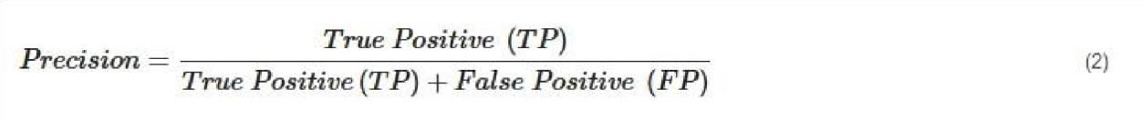

It is also defined as the ratio of the number of relevant recommended items to the number of recommended items expressed as percentages.

***Recall***. Recall can be defined as the fraction of correct recommendations or predictions (known as True Positive) to the total number of correct relevant recommendations provided, which can be as represented as follows:



It is also defined as the ratio of the number of relevant recommended items to the total number of relevant items expressed as percentages.

***F1 Score***. F1 score is an indicator of the accuracy of the model and ranges from 0 to 1, where a value close to 1 represents higher recommendation or prediction accuracy. It represents precision and recall as a single metric and can be as represented as follows:

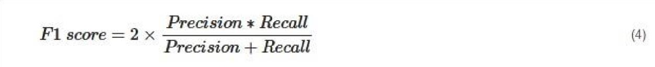

***Coverage***. Coverage is used to measure the percentage of items which are recommended by the algorithm among all of the items.

***Accuracy***. Accuracy can be defined as the ratio of the number of total correct recommendations to the total recommendations provided, which can be as represented as follows:

**10.ADVANTAGES & DISADVANTAGES**

**ADVANTAGES:**

* Smart fashion recommender application is the user friendly.
* With the help of chatbot user cand find the products very easily.
* This application used to discover the product based on the user’s choice, very easily

and quickly.

* It have ability to reduce transaction costs for consumers, and increase revenue for retailers.

**DISADVANTAGES:**

* It need active internet connection.
* Privacy concerns.
* Too many choices.
* Cold-start problem.

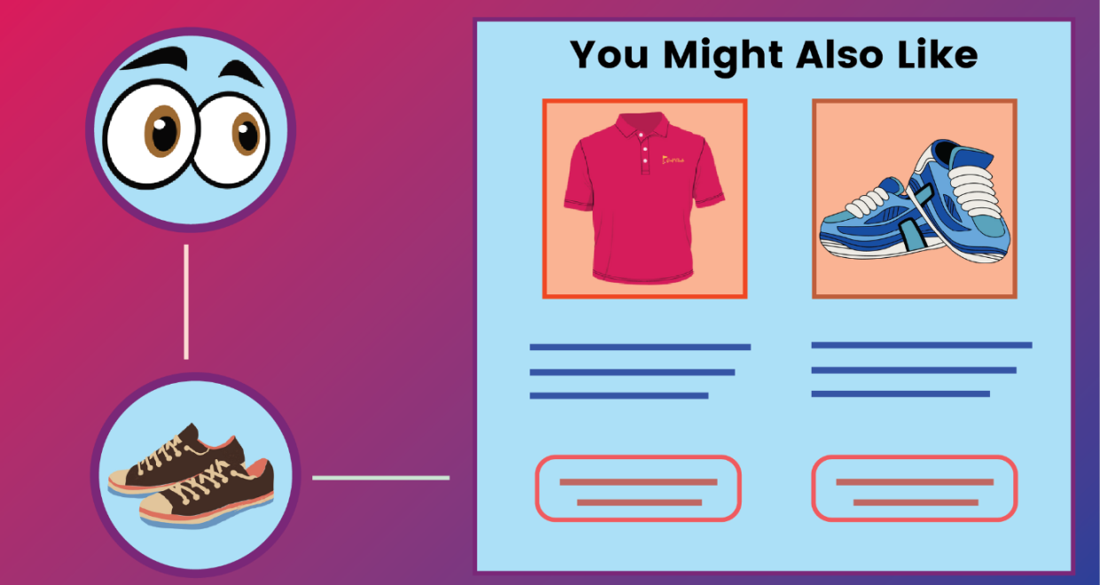

# 11. CONCLUSION

The Fashion Recommendation System is mainly used to recommend the best possible outfit combinations to a user who has no fashion sense based on their wardrobe . It may not always provide the best possible outfit to wear for an occasion as the system is dependent completely on the clothes present in the user’s wardrobe. Also another reason is that fashion is highly dependent on the time period. However the system does a great job in inculcating a fashion sense among the users and can provide the best recommendations based on the user’s wardrobe. Since the system is implemented as a website, it is very easy for the end users to access as well as use. The scope of this system can be expanded by including the ability to detect the various design and patterns on clothing, and to increase the number of occasions.

**12. FUTURE SCOPE**

In the future, to implement this recommendation system to be extended to include male and non-binary fashion items including apparel, footwear, accessories etc. This work can further be enhanced to predict fashion items based on the skin colour and weather conditions.

Future research should concentrate on including time series analysis and accurate categorization of product images based on the variation in colour, trend and clothing style in order to develop an effective recommendation system. The proposed model will follow brand-specific personalization campaigns and hence it will ensure highly curated and tailored. offerings for users. Hence, this research will be highly beneficial for researchers interested in using augmented and virtual reality features to develop recommendation systems.

**13.APPENDIX SOURCE CODE:**

**LOGIN:**

<html>

<head>

<meta name="viewpoint" content="width=device-width, initial-scale=1.0">

<title>SOLO SHOPPING </title>

<link rel="stylesheet" href="https://storagedemo-madzh.s3.jptok.cloudobjectstorage.appdomain.cloud/Regcss.css">

</head>

<body>

<div class="main">

<div class="navbar">

<div class="menu">

<ul>

</ul>

</div>

</div>

<div class="content">

<h1> SMART FASHION <br><span>APPLICATION</span></h1>

<div class="form">

<h2>FASHIONZZ LOGIN</h2>

<form action="/Login" method="post">

<input type="text" name="username" placeholder="ENTER

USERNAME">

<input type="password" name="password" placeholder="ENTER

PASSWORD">

<button type="SUBMIT" class="btnn"><a href="#">LOGIN</a></button>

<p class="link">DON'T HAVE AN ACCOUNT<br>

<a href="/Register">SIGN UP </a> HERE </></form></div>

</div></div>

</body>

</html>

**GITHUB LINK:**

# *https://github.com/IBM-EPBL/IBM-Project-42814-1660709689*